FCH2 - FCH2 - Display For Payment Document

Functionality
This transaction allows you to display more detailed check information via the payment document number. From the check information display, you can request details on the check recipient and the check issuer as well as branch to display of the corresponding payment and invoice documents.

Scenario
You want to display the payment document that underlies previously posted check.

Requirements
A recorded check and a related posted payment document.

Menu Path | Accounting → Financial Accounting → Accounts Payable → Environment → Check information → Display → FCH2 - For payment document
Transaction Code | FCH2

1. Double click on FCH2 - For payment document.

Payment Document Checks

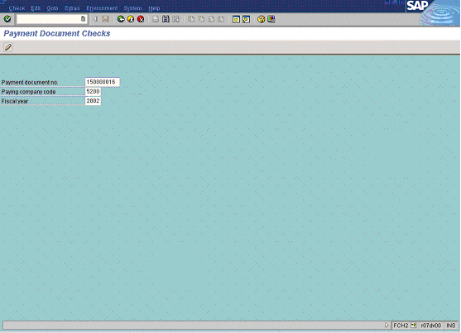

2. Update the following fields:

Field Name | Field Description | Values
Payment document no. | Payment document posted by a check transaction (e.g. F-58) | Example: 150000016
Paying company code | In this field you find the company code that processes the payment transactions (possibly for other company codes too). | Example: 5200
Fiscal year | Fiscal year number | Enter value in Fiscal year.  Example: 2002

3. Click Enter Button to confirm your entries. The system will display the check details:

Display Check Information

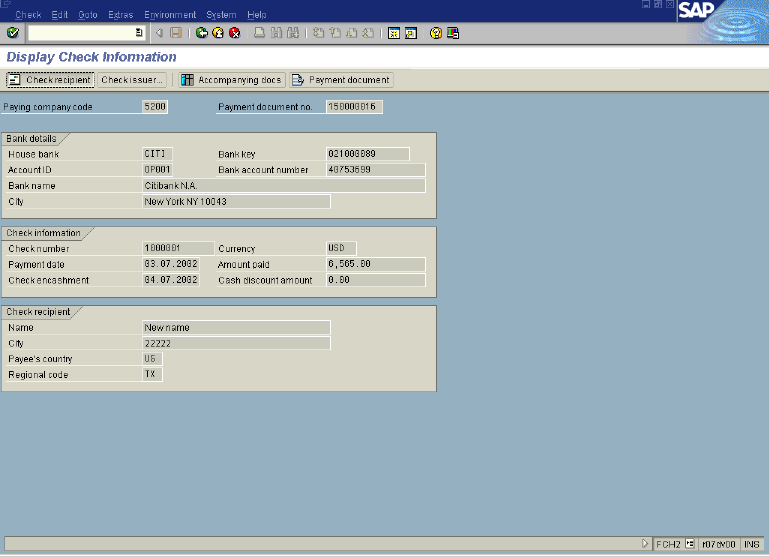

4. Click Check recipient Button . The system will display for whom the check was issued:

Check Recipient

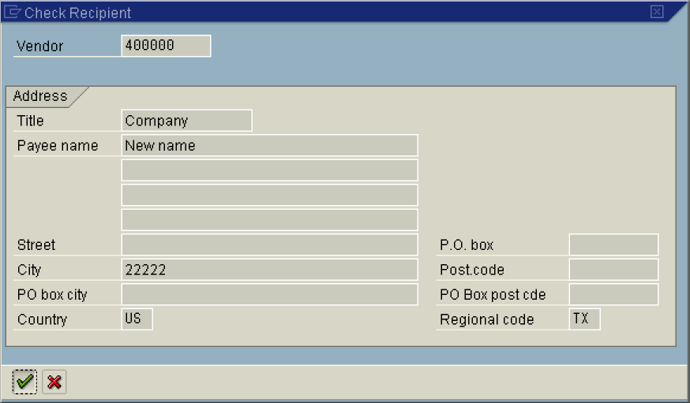

5. Click Enter Button. to close this screen.

Display Check Information

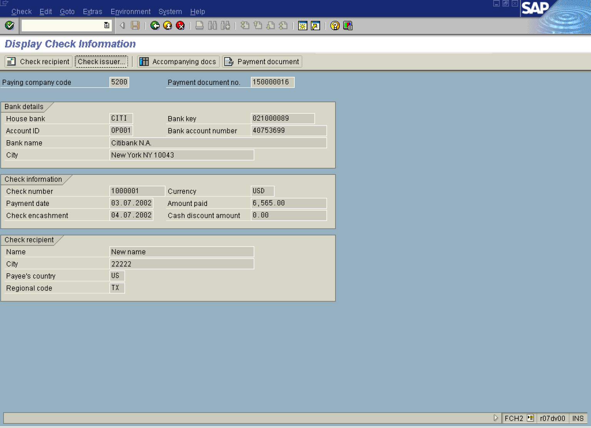

6. Click Check issuer... Button . You will see the user details that posted the check transaction:

7. Click Enter Button.

Display Check Information

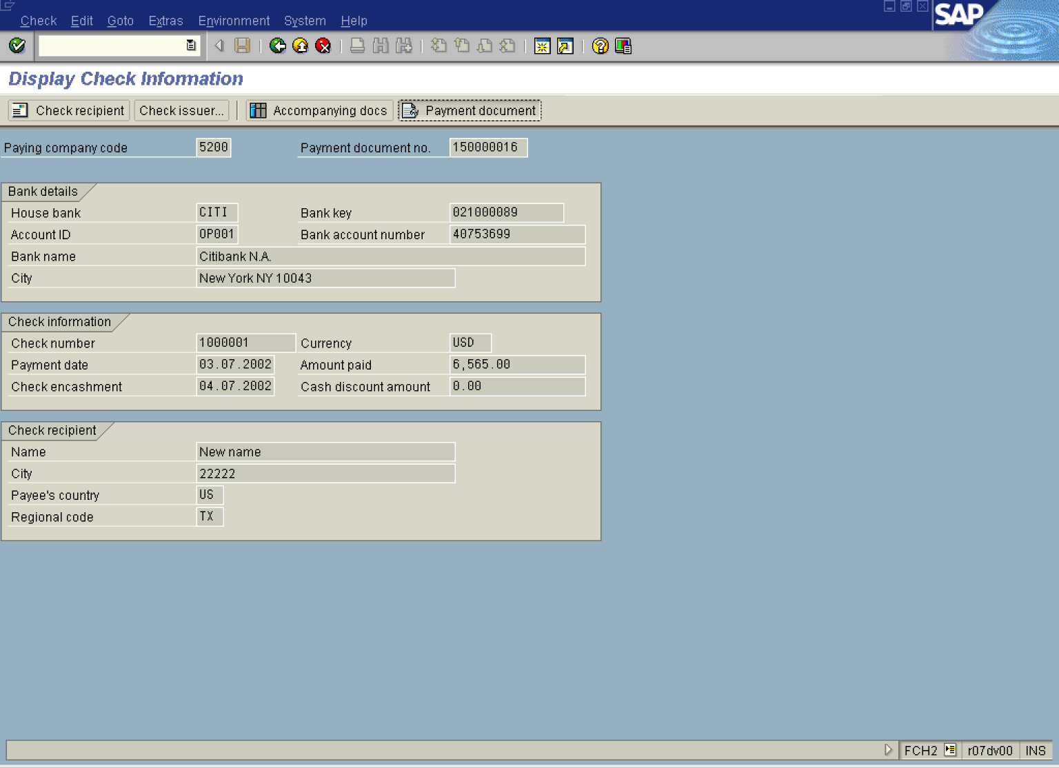

8. Click Payment document Button . The system will display an overview of the accounting document posted when the check was issued:

Display Document: Overview

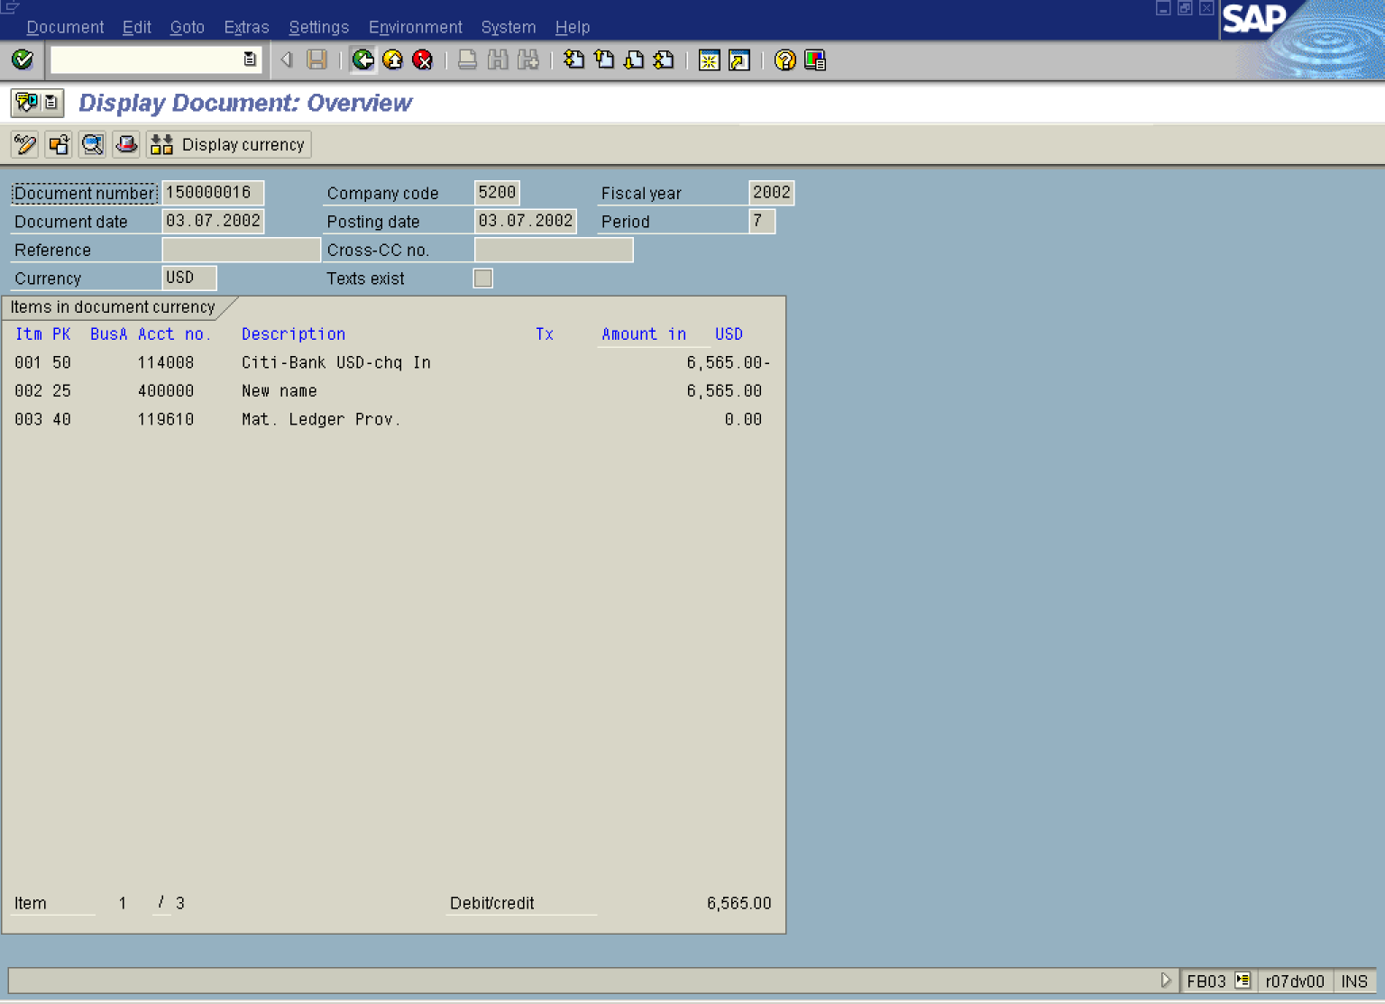

9. Click Back Button .

Display Check Information

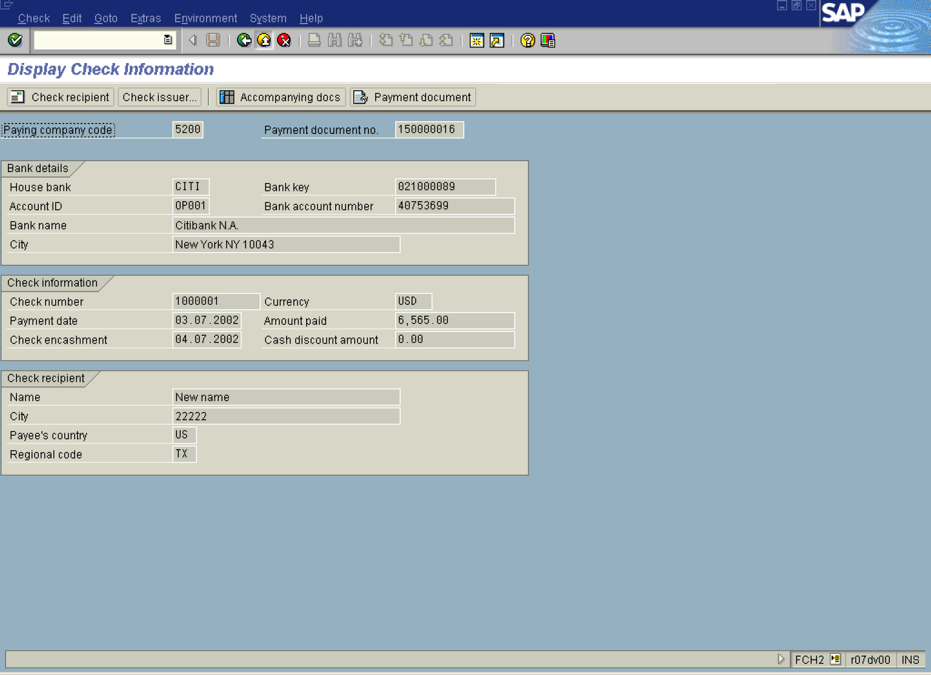

10. Click Exit .

